PRESS RELEASE
26.11.13

Focusrite at the hub of Young Guns' Project Studio
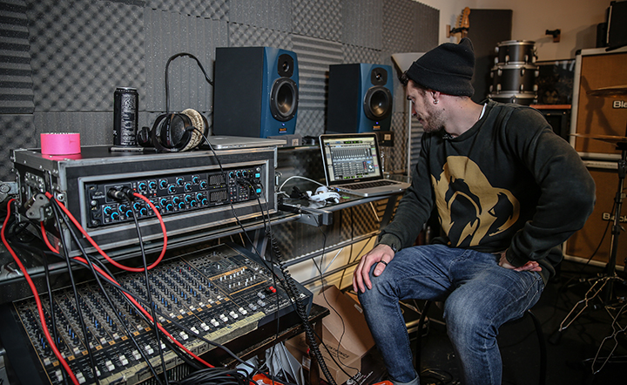
Billboard-topping five-piece rock band Young Guns are currently writing and demoing for their third full-length album and are using Focusrite’s Firewire/Thunderbolt* Saffire Pro 40 audio interface and OctoPre MkII Dynamic preamps/compressors at the hub of their home recording studio based in Marlow, UK.

Their recording/rehearsal space - which was constructed by the band themselves - acts as their central writing and practice facility, and is where they have written most of their material including their debut EP “Mirrors”, first full-length “All Our Kings Are Dead” and second full-length “Bones”.

When approaching the writing process for the band’s third full-length album they decided they wanted to take more creative control in terms of production, and for that they required a great sounding, comprehensive and easy-to-operate audio interface solution.

“The idea was to allow us to put down solid demos in our own time” says guitarist John Taylor. He continues, “We wanted to be able to multi-track record live performances as a whole band as well as track great sounding drums, guitars, synths and vocals for demos.”

Focusrite’s Firewire/Thunderbolt* Saffire Pro 40 audio interface, which includes eight award-winning Focusrite preamps, 10 analogue outputs, ADAT I/O, S/PDIF connections, two DI channels, a dedicated stereo monitor mix output and two independent headphone buses ticked all the boxes in terms of an ideal audio interface. For added channel count expandability they also chose Focusrite’s OctoPre MkII Dynamic, which they connect via ADAT giving them eight more channels of Focusrite mic preamps with a VCA-based compressor on each channel.

“Getting to grips with the gear was really easy” says lead singer Gustav Wood. He goes on to explain that John assumes control of most of the band’s engineering duties, but the rest of the band feel empowered to record their own ideas with their new set-up.

John comments, “Initially we spent some time setting up headphone mixes and routing options in Saffire Mix Control, as well as micing up instruments and playing with levels…Once this was done, we simply saved the presets and could concentrate solely on the music.”

In terms of connectivity, the band connect the Saffire Pro 40 to their MacBook via a Firewire to Thunderbolt adaptor. John explains that his new MacBook doesn’t have any Firewire ports on it, but the interface connects seamlessly using a standard Firewire to Thunderbolt adaptor cable.

Commenting on the sound quality, John says, “The mic preamps sound amazing…they are smooth and transparent, and unlike other audio interfaces we have used in the past we haven’t had any problems with noise or distortion.”

For recording drums the band are taking advantage of the OctoPre MkII Dynamic’s on-board compressors, which help to add life and character to drum takes on the way in.

Gustav concludes, “Being able to record our demos at such a high standard is a real step up for us as a band… We feel more confident when coming into the studio with solid ideas…Having our own recording set-up allows us to workshop our songs to a whole new level.”

Young Guns embark on a UK arena tour with Bullet For My Valentine and Asking Alexandria at the beginning of December before hitting the studio to start tracking their third full-length album.

*Compatible with the Apple FireWire to Thunderbolt™ adaptor (not included)

Contact: Hannah.bliss@focusrite.com (US)
Will.evans@focusrite.com (UK)

